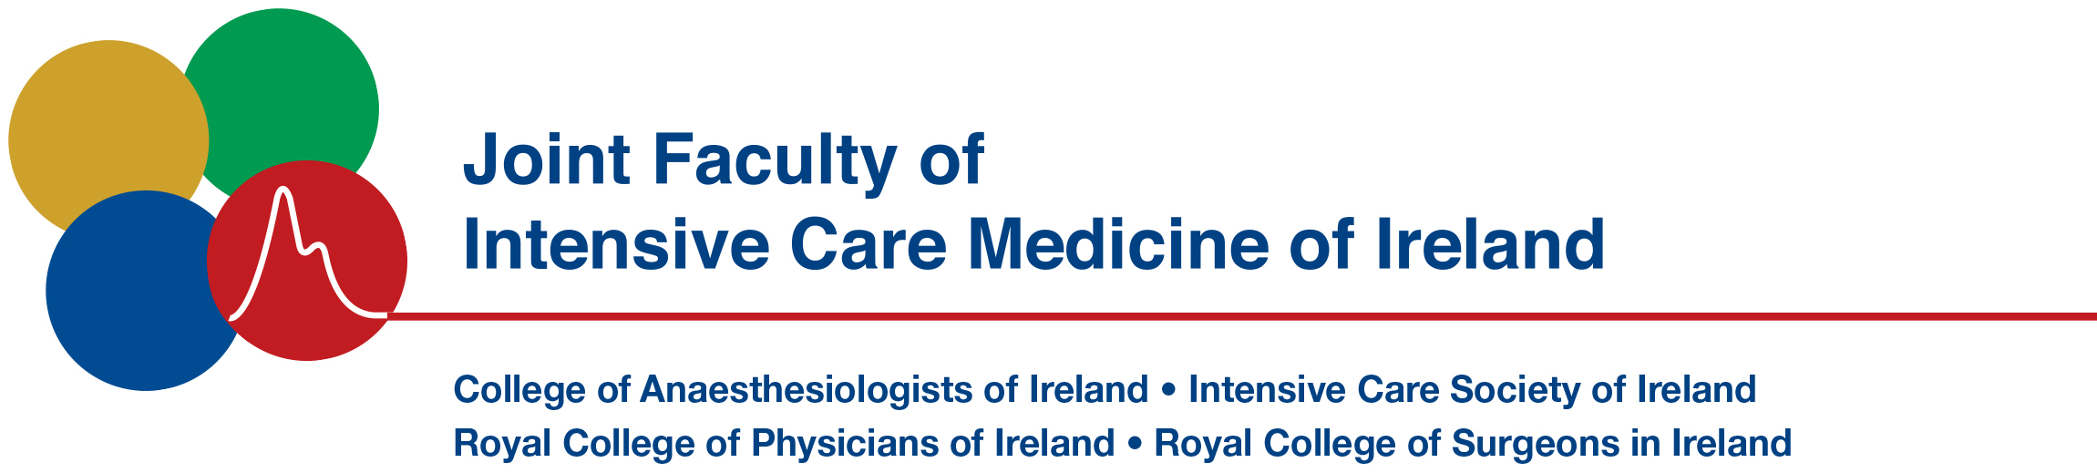

Name of meeting: | Irish Donor Awareness Programme IDAP
 | 12th May 2023 Virtual Meeting Via Zoom

Registration €75.00* Free for JFICMI exam candidates

Surname: |  | Forename:

Address:

Contact Number / Email address: | +353 _________________________________

*Payment will be taken via a virtual portal that will be emailed to you some weeks in advance of course commencement.

Please return completed application form to jficmi@coa.ie

