WESTERN ANAESTHESIA SYMPOSIUM 2022

FUSIC Heart-GUH Programme

Glenlo Abbey Hotel- Galway - 25th March 2022

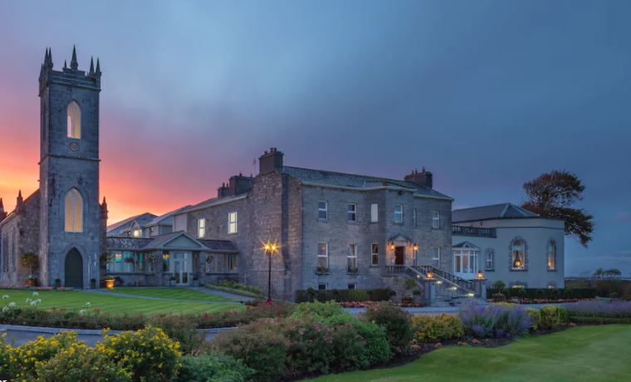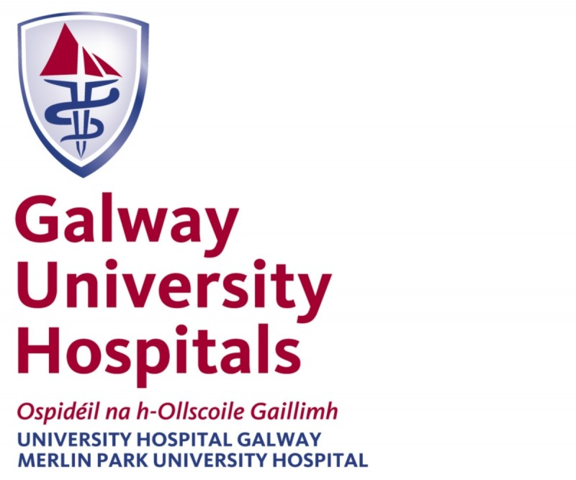

Faculty:
Dr Peter Moran Consultant in Anaesthesia and Intensive Care Medicine - GUH
Dr Ciara Hanley Consultant in Anaesthesia and Intensive Care Medicine - GUH
Dr Rachel Jooste Consultant in Anaesthesia and Intensive Care Medicine - GUH
Dr John Bates Consultant in Anaesthesia and Intensive Care Medicine – GUH
Dr Michael Callaghan Consultant in Anaesthesia – GUH
Dr Bairbre McNicholas Consultant in Nephrology and Intensive Care Medicine – GUH
Dr Jonathan Roddy Fellow in Intensive Care Medicine - GUH
Peter Conneely Medical Physicist GUH

8:00 – 08:15 Registration
08:15 – 8:45 Introduction to ICU echo – Peter Moran/Peter Conneely
Windows & anatomy
Physics of US
Image optimization
FUSIC Heart – proforma

8:45 – 9:45 Live imaging demo – interactive session – Peter Moran and John Bates
Basic and advanced views
9:45 – 10:15 The left heart – Bairbre McNicholas
10:15 – 10:30 Coffee Break
10:30 -11:00 The right heart – Ciara Hanley

11:00 – 12:00 Scanning session 1
12:00 – 13:00 Lunch
13:00 -13:30 Volume assessment – Peter Moran

13:30 – 14:00 Pericardial & pleural fluid – John Bates
14:00 – 15:30 Scanning session 2

