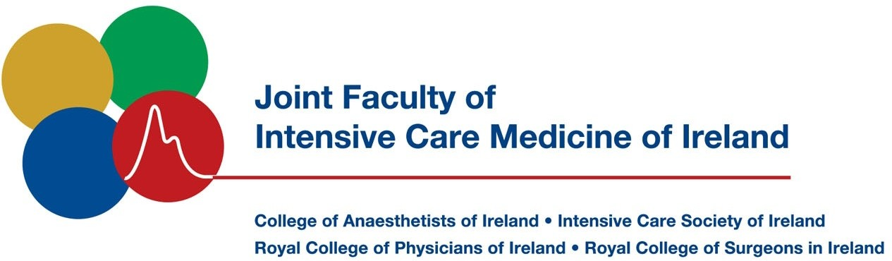

JFICMI Fellowship Exam Format – WRITTEN and CLINICAL / VIVA EXAM
(February 2021)

INTRODUCTION

The examination consists of an initial written component (part 1) after which, the candidate may be invited to attend for the Clinic / Viva exam (part 2), usually 3-4 weeks later. The dates will already have been pre-announced by the Joint Faculty’s Examinations Committee at the beginning of the year.

Section | Sub-section content | Time allowed | Closed mark
Part 1 | MCQ (50 single best answer questions) | 90 minutes | 5
 | SAQ written paper (8 short answer questions) | 120 minutes | 5
Part 2 | Clinic-Major Case 1 | 30 minutes | 5
 | Clinic- Major Case 2 | 30 minutes | 5
 | Viva 1 (Radiology, lab tests, traces, curves) | 30 minutes | 5
 | Viva 2 (Intensive care medicine) | 30 minutes | 5

Part 1: MCQ and SAQ PAPERS

Both of these sections are examined on-line. Each candidate will be invited to do a trial run prior to part 1 where issues regarding software and navigation through the on-line process can be addressed for each candidate. Each candidate will have to sign a consent form allowing the examination administrators proctor the exam by use of video camera on the device of the candidate. This will be stored for a period by the College of Anesthesiologists of Ireland until the examination validation and marking is completed by the Chair of Examinations of the Joint Faculty of Intensive Care Medicine of Ireland.
The MCQ exam consists of 50 Single Best Answer (type-A MCQs) the short answer question (SAQ) paper consists of eight questions, which require 10 - 12 minutes of written response. The nature of the SAQ paper is best appreciated by viewing the Faculty’s SAQ papers from previous years – see appendix 8b of the Faculty’s submission to the IMC Feb 2015 for papers for the five years 2010-2014. The subjects of both the MCQ and SAQ exam questions are drawn from the curriculum of the intensive care training program of the JFICMI.
The pass-mark of both the MCQ and SAQ are determined by the Angoff method of standardisation. This is carried out prior to the exam by about 6 to 8 experienced examiners and each examiner is blinded from each other. Using the Angoff pass-mark as a reference, the closed mark for each candidate is calculated using the standard deviation for that part of the exam.

If a closed mark of 5 (or greater), between the MCQ and SAQ, has been achieved, the candidate is invited to progress to the part 2 of the exam. This is a separate application process. Candidates may defer for 1 year only. If a candidate does not apply to part 2 the following year, s/he will have to sit part 1 again. However, as a 0 closed mark (veto) in any part of the exam automatically disqualifies a candidate from passing the exam outright (cannot be compensated elsewhere), the composite marks in part 1 must be at least a closed mark of a 1 and a 4 to qualify to apply to part 2.

When such a candidate receives the invitation to proceed to the Clinic / Viva examination, s/he will be notified of which hospital to attend well in advance of the date. Please dress professionally and in attire, which is suitable for clinical activity. Exam invigilators will guide the candidate through the components of the clinical exam – the major cases.
The Vivas are normally held at 22 Merrion Square North, Dublin 2 in the afternoon, but may be held at hospitals.

Part 2: CLINICAL EXAM (Major Cases 1 and 2):

The major cases clinical examination in ICU will last for 30 minutes each (60 minutes in total). This component of the exam is usually conducted in the morning and is normally held in one (or two, or three) of four or five major hospitals in Dublin or Belfast, which are accredited for training in Intensive Care Medicine in Ireland by the Joint Faculty of Intensive Care Medicine of Ireland.

A short pre-exam conference of examiners is held in the hospital(s) on the morning of the clinical examination. General orientation, reiteration of the marking system and confirmation of the clinical signs on which the candidate will be evaluated is the primary purpose of this meeting.

Nature of clinical cases:

These will be substantive current Intensive Care patients

Candidate and examiners approach the bedside together. There are normally two examiners (there may be more but never less than 2), who will interact with a candidate and agree a mark before taking the next candidate. The aim of the 30 minutes of the examination is to assess how well a candidate is able to elicit clinical information which is accurate, relevant and comprehensive – within the constraints of the circumstances - and how well the candidate can tie the elicited information together, present it coherently and construct relevant differential diagnoses.

The candidate should address the clinical cases with a structured and experienced approach. It is expected that at this level of seniority all candidates should have matured their clinical examination approach to meet the specific needs of an intensive care clinical examination befitting a specialist. The examiners shall be attentive to the appropriate eliciting of clinical signs, and to the candidates’ interaction with the intensive care environment. Whether a candidate describes what he/she is doing during the examination is up to each individual candidate: neither are additional marks given for commentary nor will marks be docked because the candidate performs his/her examination without commentary.

The process mimics a practical ICU handover situation. Appropriate questions are expected from the candidate as per a Consultant / NCHD handover relationship (the examiners taking on the role of NCHD). The examiner shall provide answers to the candidate provided such questions focus on the clinical context and are not deemed “random” in nature. However, random questions without a clinical context to that particular case will be marked down.

Similar to a routine handover, the candidate will need to ascertain supplementary details from the clinical notes/clinical information system and prescription record, but must ensure sufficient time for a comprehensive clinical examination.

At the 25 minute mark, the candidate will be expected to briefly present the case with a focus on the clinical questions posed, and formulate a relevant clinical plan for the patient.

The last 5 minutes of each 30-minute clinical major case shall allow a brief focused discussion on the case with a number of questions posed to the candidate by the examiners.

Notes:

This section of the exam is primarily physical examination-based but includes information to be gained from around the bedside e.g. from tubes, bags, sputum containers, machines and monitors.

The approach of the candidate to the patient in terms of professionalism, politeness, patient dignity and ensuring that no pain or indignity is caused the patient is considered fundamental.

The candidate should complete a structured clinical examination with due respect for the staff and environment (e.g. showing compliance with isolation and infection control procedures where applicable).

The candidate will be asked to make management evaluations and suggest and discuss therapeutic options in a manner becoming of a Consultant in Intensive Care Medicine or with a Special Interest in Intensive Care Medicine.

It is not the section of the exam where general knowledge or knowledge of ECGs or chest X-rays is evaluated. Another section of the exam (see Viva 1 below) is designed specifically to evaluate these areas.

Part 2: VIVAS 1 and 2

The Viva component is normally conducted in the afternoon – usually, but not necessarily, at 22 Merrion Square North, Dublin 2. There are two vivas of 30 minutes duration with each (of two) examiners being given 15 minutes to ask questions. The two examiners are obliged to agree a joint mark at each table before taking the next candidate. A third observing examiner may sit in (e.g. the Chair of the exam, the Extern or a trainee examiner).

VIVA 1 ECGs, X-rays, Laboratory results, Clinical Traces 30 mins

This section of the examination is standardised and consists of evaluating the candidates’ capacity with various clinical investigations as utilised in Intensive Care Medicine. It will include ECGs, radiology (including CXRs, CT scans, echocardiography and ultrasound) and various laboratory test scenarios (e.g. biochemistry, acid/base, haematology etc.) which are usually presented on a computer screen. Additional clinical investigations / measurement questions may be used at the discretion of the Examination Committee including curves, graphs and diagrams that are pertinent to the practice of intensive care medicine. The examiners take all candidates through these pre-set investigations / scenarios in a standardised manner.

VIVA 2 Intensive Care Medicine 30 mins

This is a broad – based section of the examination whereby a series of question formats and sequences are given as options to the examiners before the exam. Usually three options are addressed per examiner.

Questions utilised in this section of the exam are of broad relevance to ICM, its evolution, administration, ethics, audit and research priorities. Example include questions relating to Severity of illness scoring, Standardised mortality ratios, Importance of individual elements of a ‘care bundle’ (such as that of the surviving sepsis campaign), Antibiotic stewardship in ICU, Intensive Care Training e.g. CoBaTrice, End of life care and management and quality improvement / management. In addition, questions will be asked on clinical intensive care medicine.

The examiners choose from the pre-set scenarios and each examiner takes the candidate through a pre-set sequence of questions but some relevant diversion is acceptable. The candidate has 15 minutes with each examiner; the other does the marking. A final mark is agreed between the two examiners before taking next candidate.

CONCLUSION

After the exam, the “court of examiners” meet and, in accordance with the marking system outlined in the Faculty’s exam Organisation document, arbitrates as a group on the outcome of the exam. Fail marks are scrutinised carefully and need to be justified in writing by examiners. The Faculty medal is awarded to the candidate with the highest mark, provided it is 25 or greater – see marking system in Exam Organisation document. Results are announced immediately afterwards and successful candidates are invited to meet the examiners. The Chair of the Examination will meet those who have not been successful and offer information on their performance in the exam and any appropriate advice / counselling sought by the candidate.

end

