JFICMI Basic Critical Care Echocardiography (BCCE)

2020

Introduction

The “International expert statement on training standards for critical care ultrasonography” position paper published in Intensive Care Medicine 2011 set a standard that “basic critical care echocardiography [basic CCE] should be mandatory in the curriculum of intensive care unit (ICU) physicians. It is the role of each critical care society to support the implementation of training in GCCUS and basic CCE in its own country”.

There are certain challenges around this, including the limited numbers of potential mentors and limited ICM modular training time. Over recent years there has been considerable expansion of Transthoracic ECHO performed by Intensivists in Ireland with an expansion therefore in the potential mentor base. In parallel with this there has been an expansion in availability of suitable Echo machines. Other jurisdictions have been presented with similar challenges and the FOCUSED INTENSIVE CARE ECHOCARDIOGRAPHY (FICE) addresses some of these. In particular, this JFICMI Education and Training Committee proposal has adopted the mentor solution of the FICE programme (see below). The level of competency to be achieved is derived from the CoBatrice Coba Echo domains.

The JFICMI shall provide for recognition of Basic CCE at defined training sites. Certification at such sites shall support the ability of a candidate to progress to advanced CCE training and accreditation, including the new ESICM EDEC accreditation process which has an entry requirement of certification in basic CCE, and hence an imperative the JFICMI develops such a programme.

Candidates:
- Candidates are registered JFICMI trainees
- Consultants with an Interest in Intensive Care Medicine
- Consultants in Intensive Care Medicine.

Course:
All candidates must attend a recognized Basic Echocardiography course within 12 months of first logbook entry. The JFICMI is happy to review and approve national and international basic CCE. This is usually a 2 day course with a combination of didactic lectures (approx. 10 hrs), clinical examples and hands on training with volunteers.

Hands-On Training:
Although sites may vary, hands-on training is likely to be modelled on a 6-months 2 hours/week “Hands-on” formal instruction (approx. 40hrs) and mentored personal experience over the same period.

Mentors and Supervisors:
Each approved basic CCE training site shall be able to provide Mentors for the candidates and Supervisors for both mentor and candidate.

- Mentor
- Shall have suitable experience and regular practice in Critical Care Echo.
- Where he/she does not hold a recognized certificate in cardiac echocardiography, shall have access to a supervisor for overview of the training provided and for review of difficult cases
- Supervisor
- Shall have a recognized national or international accreditation in echocardiography.
- Shall have suitable experience and regular practice in critical care echo.
- Shall provide oversight, support and on-going training to both mentor and candidate (e.g. Peer review sessions).

Logbook
- Candidate must detail their basic CCE exams in a logbook (model format attached) and submit 30 cases for review by their Mentor.
- The logbook must be representative of the Image Acquisition and Interpretation > Knowledge domains as per Coba Echo (see below).
- The logbook should reflect some cases of RWMA, Valvular abnormality, pleural effusion, hypovolaemia etc, some of which may require a training relationship with other aspects of the hospital outside ICU depending on case-mix – e.g. Cardiac Echo Department / technicians, cardiology, cardiac theatres etc.

Practical Assessment

3 components under supervision / assessment of Mentor / Supervisor:
- Presentation and discussion of logbook signed by Mentor/Supervisor
- Demonstration of scanning ability on a simulator and a normal volunteer.
- Assessment of the correct interpretation of video loops containing key acute care pathologies.

Basic Echocardiography Training Programme

Instrumentation

Knowledge
- Lecture ‘How to optimize the standard Echo image’ or ‘Knobology’ should incorporate enough physics to use any Echo machine.
- Infection control precautions
- Care of the ultrasound machine including cleaning (transducer head special cleaning agent etc.)

Skills
- Select appropriate ultrasound transducer
- Use conductive gel to aid transmission of ultrasound wave
- Correctly adjusts depth, gain and focus position
- Identifies common artifacts

Functional approach to Echocardiography training incorporating cognitive & technical training.

For example: Mater Misericordiae University Hospital (MMUH) Basic Echo Training over six months

Months 1-2:
- Reliably acquire standard views
- Recognise whether image is adequate or not
- Identify normal and abnormal findings
- Interprets Echo findings with respect to cardio-respiratory support at time of imaging (e.g. level of vasoactive medication, IABP)

Months 3-6:

Recognise the echocardiographic features of the following syndromes:
- LV global dysfunction including cardiomyopathies
- RV dilatation and dysfunction including acute Cor Pulmonale (Pulmonary Embolism, ARDS)
- Regional Wall Motion Abnormalities (hypokinesis, akinesis)
- Hypovolaemia (IVC diameter and relationship with respiratory cycle spontaneous breathing and ventilator support. LV end-systolic cavitary obliteration)
- Pericardial Effusion including cardiac tamponade (RA & RV collapse)
- Recognise how to differentiate pericardial from pleural fluid
- Severe mitral regurgitation and severe aortic regurgitation

Additionally recognize:
- Severe calcification of the Aortic Valve
- Aortic dilatation or dissection flap in the ascending aorta

Incorporate findings with clinical picture and communicate findings:
- Start treatment, organize subsequent investigations and reassess impact of initial treatment
- Special situation: Relationship between conduct of peri-arrest Echo and the Advanced Life Support (ALS) Algorithm

Understand the indications for and limitations of Basic Echocardiography training and Transthoracic Echocardiography in general

- Some conditions better visualized using Transoesophageal Echocardiography e.g. Mitral Regurgitation due to Papillary muscle rupture, Aortic Pathology, poor image quality
- Indications for immediate expert assistance, subsequent comprehensive Echo accredited practitioner or need for alternative investigation
- Echocardiographic findings in PE usually indirect
- Finding of left sided Valvular Regurgitation, possible AS requires advanced TTE assessment

Patient Safety & Governance

Format of standard Echo report
- Importance of entering patient information, capturing images and uploading study to appropriate archiving system
- Need to quality assure Echo reports
- Relevance of Date Protection Act to image storage

References:

- International expert statement on training standards for critical care ultrasonography. Expert Round Table on Ultrasound in ICU. Intensive Care Med (2011) 37:1077-1083

- Focused Intensive Care Echocardiography (FICE) http://www.ics.ac.uk/ICS/fice.aspx

- ESICM CoBatrice: http://www.esicm.org/education/cobatrice.

Sample Log Book

Basic Level
Critical Care Echocardiography
Log Book

Please ensure your logbook has:
30 anonymised cases collected for a maximum of 12 months which should include the normal case-load of acutely unwell critical care patients;
  - At least 5 cases of Left ventricular dysfunction
  - At least 3 cases Right ventricular dysfunction
  - At least 2 cases of Mitral valve disease
  - At least 3 cases of Hypovolaemia
  - At least 1 Pericardial effusion
  - At least 2 Aortic valve disease
May include 3 normal studies

Case Study #_________ Date of Study __/__/____ Images saved echo machine: ______________
Age:____Weight: ______ HR /rhythm:____________BP:_______ CVP:______ Lactate: ___mmol/L
Indication:_________________________________________________________________________
Clinical History:_____________________________________________________________________
Vasoactive Medications:______________________________________________________________
Settings: Mechanical Ventilation _____________CPAP___________BiPaP______________________
Windows: PLAX PSAX APICAL 4-C SubCostal
(Grade image quality per window: Good = 1; Adequate = 2; Poor = 3)
Chambers

Left Ventricle (LV):
LV visually dilated: Y/N LVEDd_______mm LV wall hypertrophy: Y/N
LV function: Normal LV function depressed: Mild/Moderate/Severe
Fractional Shortening %_____ Ejection fraction %: Visual
Global Wall Motion Abnormalities(WMA’s) : Y/N
Right Ventricle (RV):
RV dilated: Y/N
RV global hypokinesis: Y/N TAPSE______mm
Valves

Aortic Valve: Native/ normal Prosthetic Calcified Possible Vegetation
Colour Flow Regurgitation(AR): None /Mild/Moderate/Severe
Mitral Valve: Native/normal Prosthetic Annular calcification/leaflet calcification
Leaflets Flail/Prolapse Possible Vegetation
Colour Flow Regurgitation(MR): None/ Mild/Moderate/Severe
Tricuspid Valve: Normal Leaflets flail/prolapse Possible vegetation
Colour Flow Regurgitation (TR): None/Mild/Moderate/Severe
©Dept. Critical Care Medicine, Mater Misericordiae University Hospital
Pericardium

Pericardial Effusion: Y/N Max. diameter diastole: ____mm
RA diastolic collapse: Y/N RV diastolic collapse: Y/N IVC dilated (> 2.5 cms) Y/N
Volume Status

LV PSAX: End systolic cavitary obliteration: Y/N
IVC : Diameter: _______mm
Cardiac Output

LVOT diam. diastole______mm

Other

Ascending aorta: Normal/ Dilated/Flap Intracardiac mass: Y/N Pacing wire/PAC/ECMO cannula

Summary findings: ________________________________________________________________________________________________________________

Clinical Recommendations__________________________________________________________________________________________________________________________________________________

Trainee Signature:__________________________Supervisor Signature:_______________________
Date: __ /__ /__

©Dept. Critical Care Medicine, Mater Misericordiae University Hospital
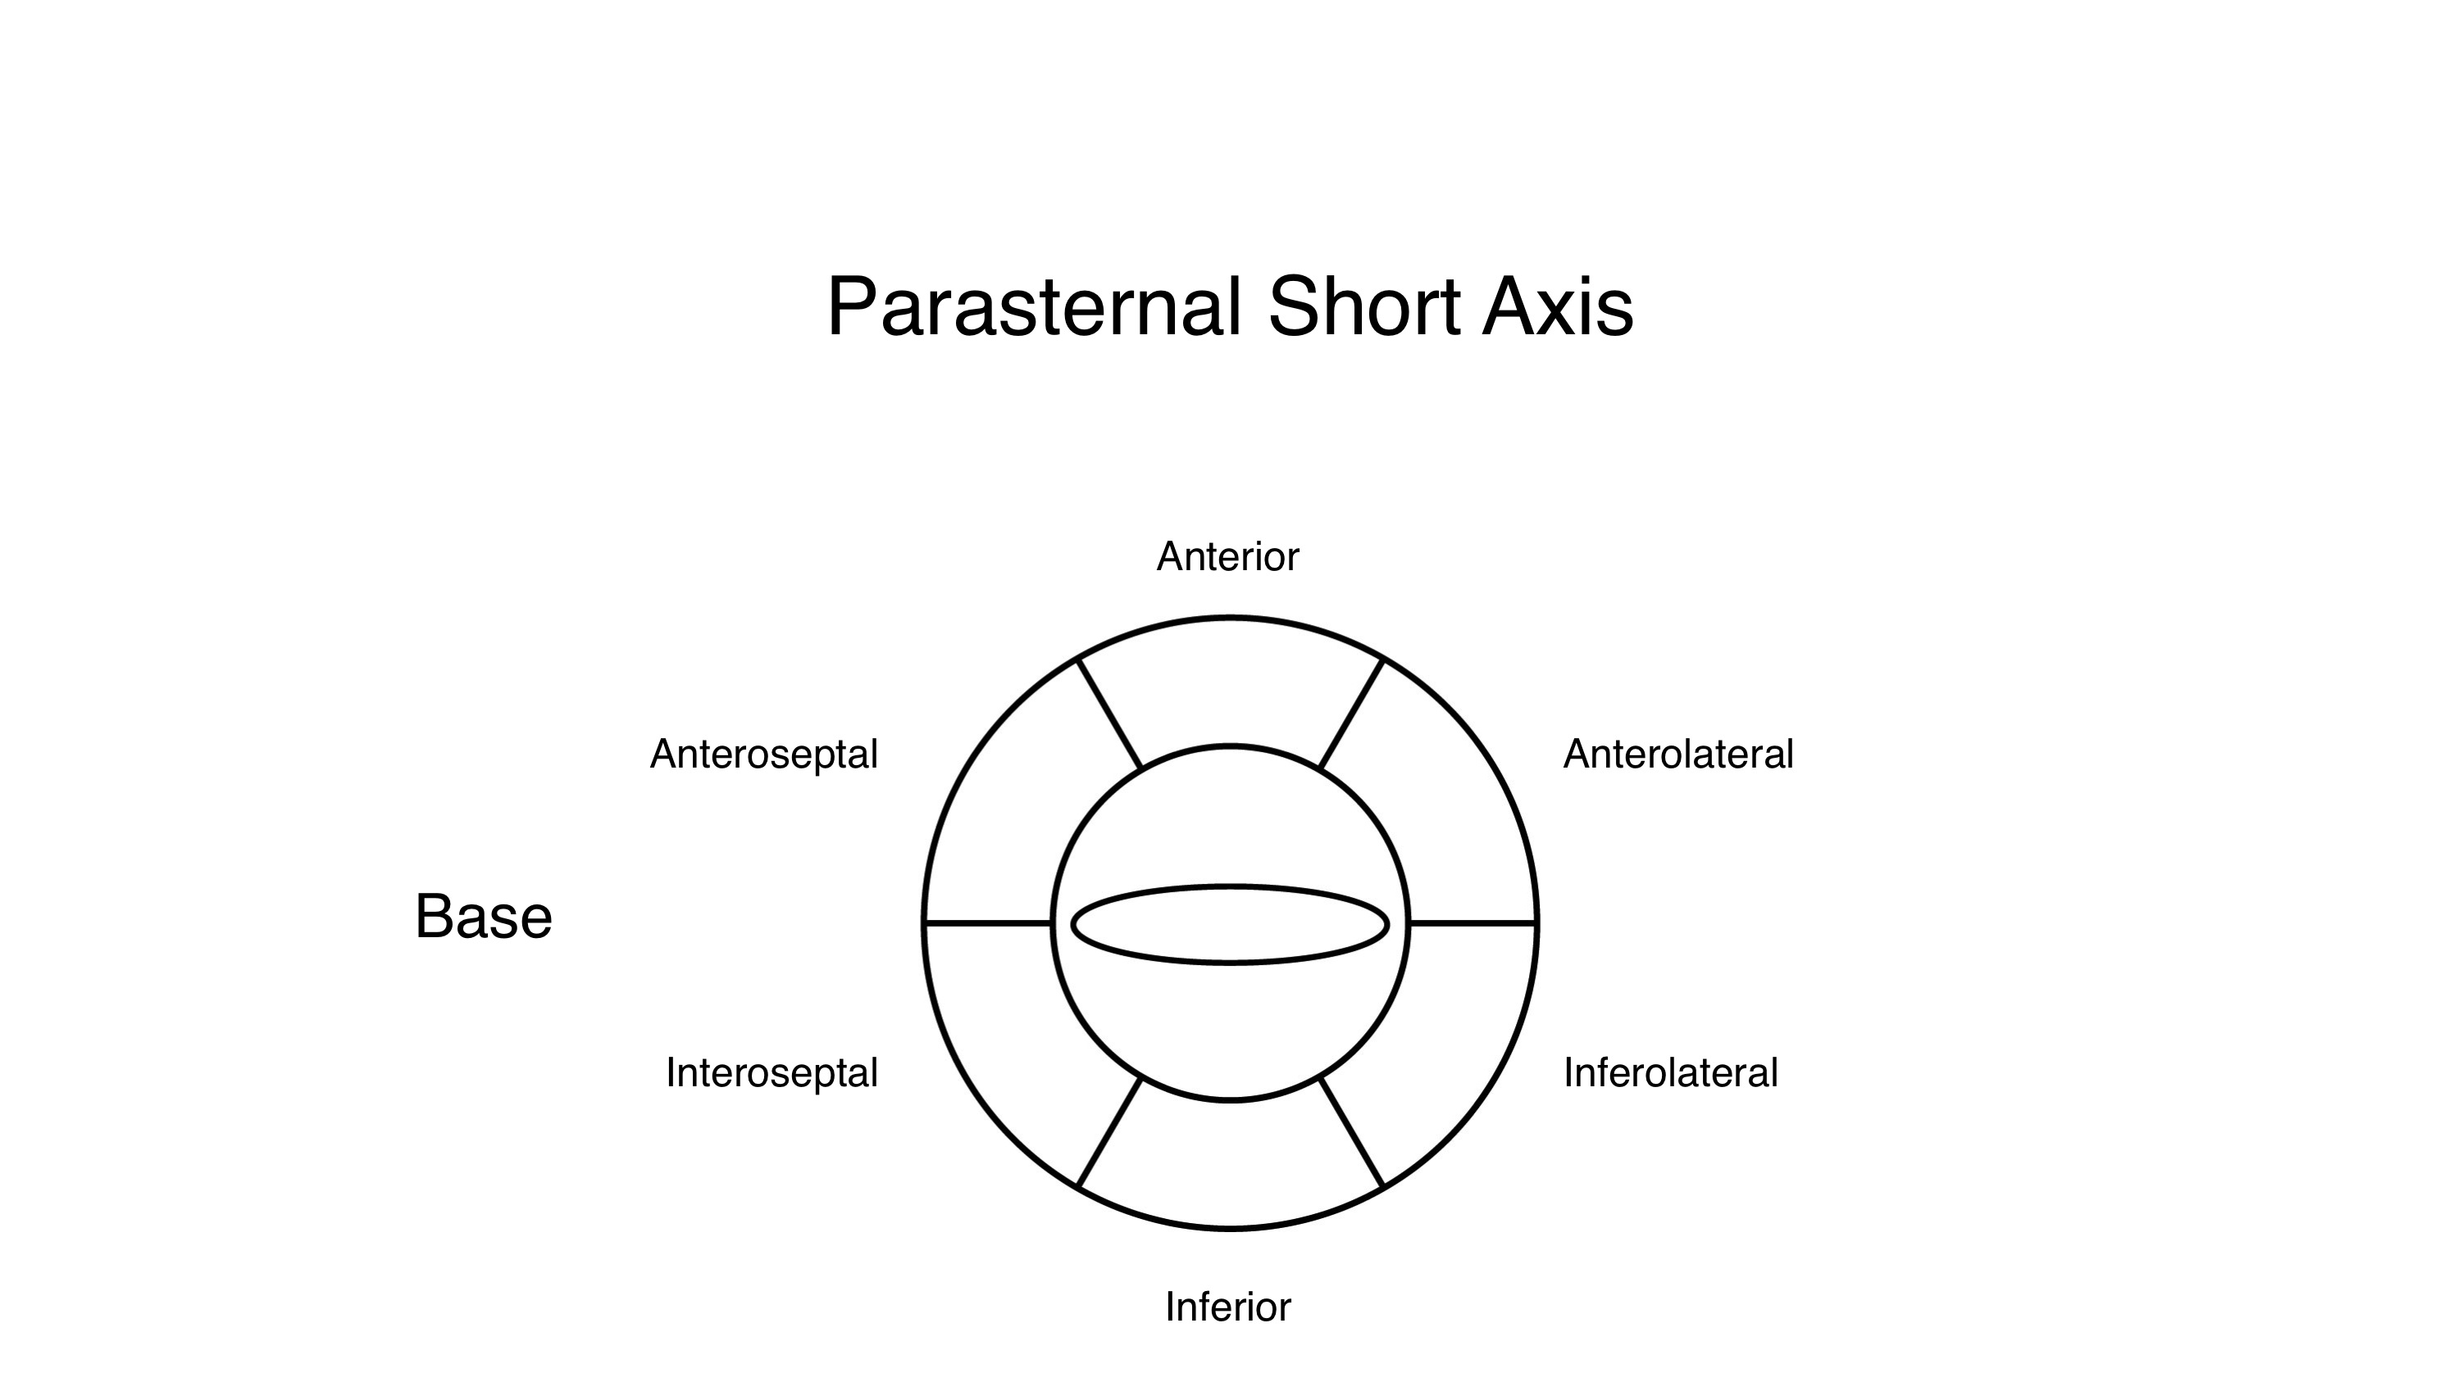
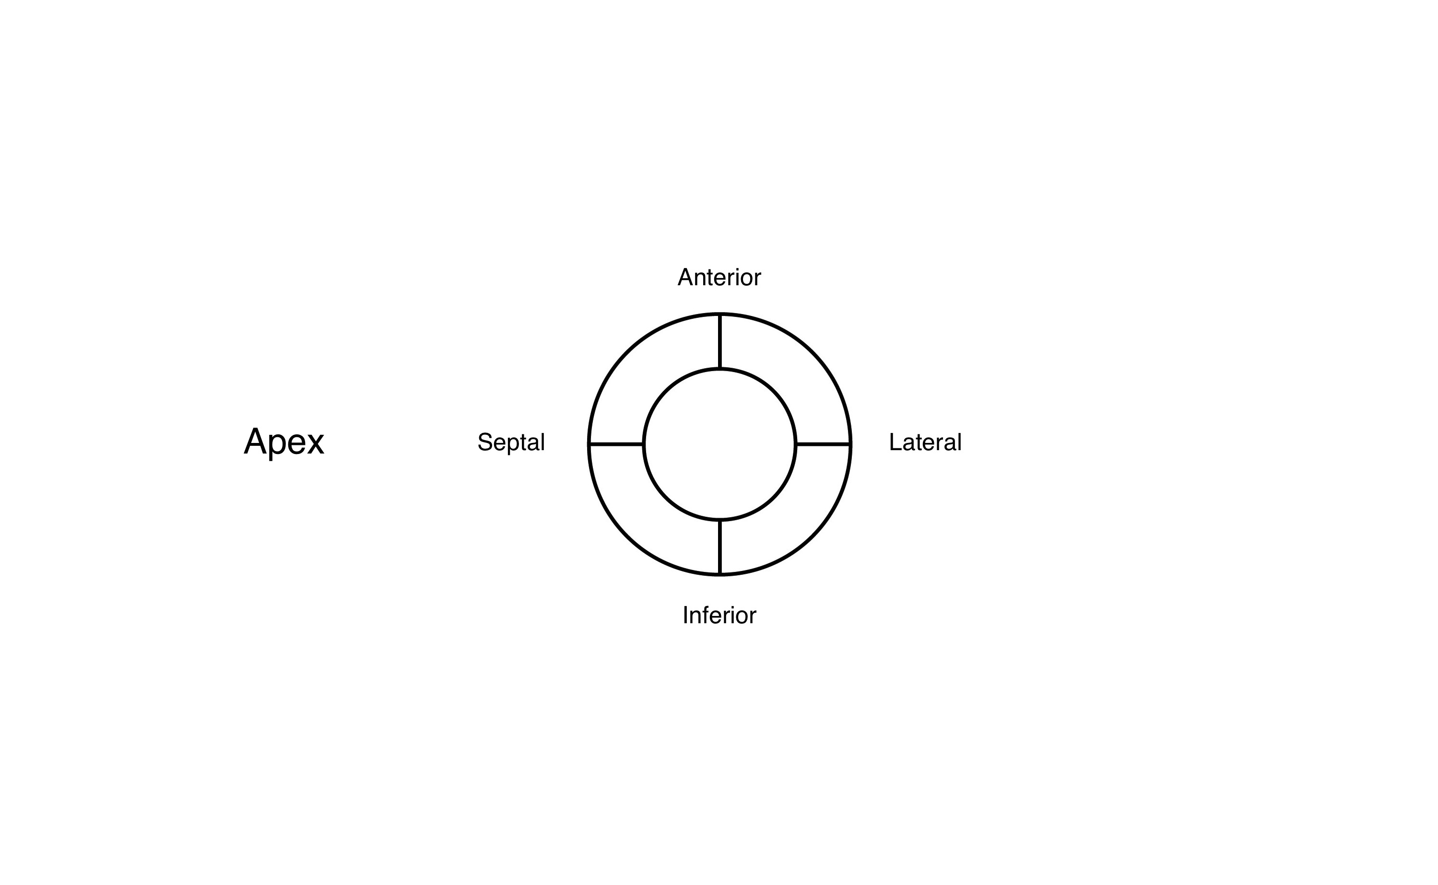
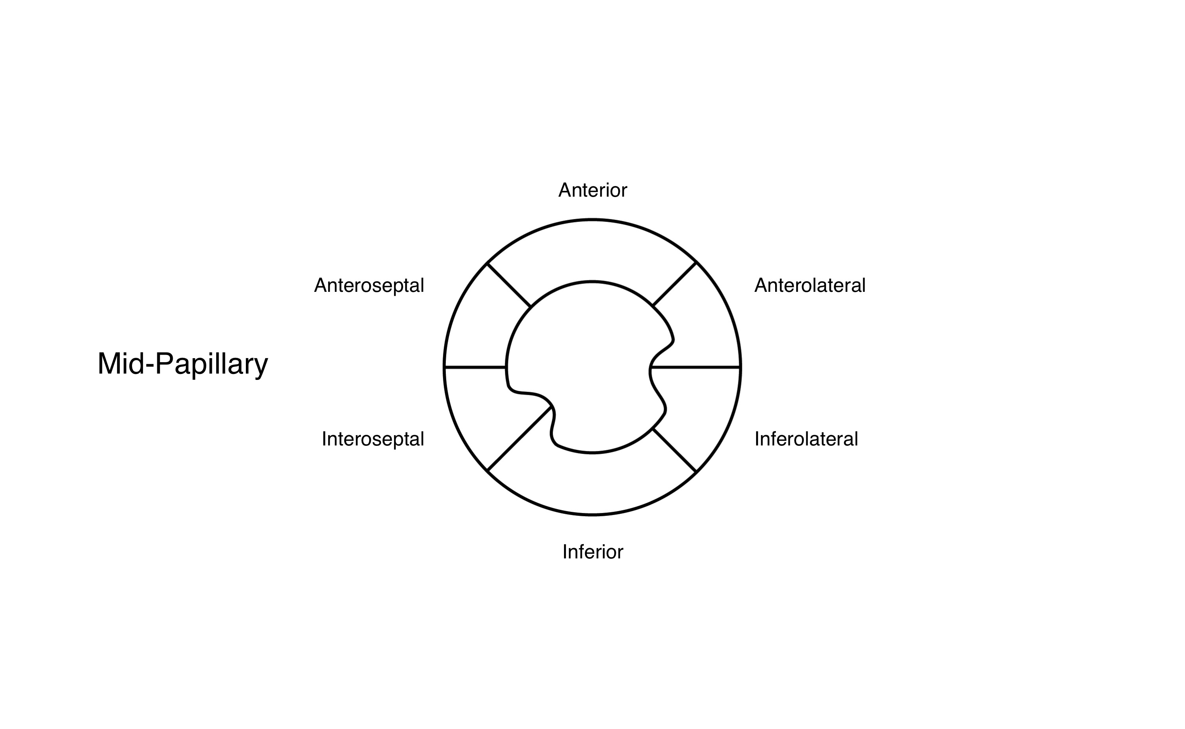

©Dept. Critical Care Medicine, Mater Misericordiae University Hospital

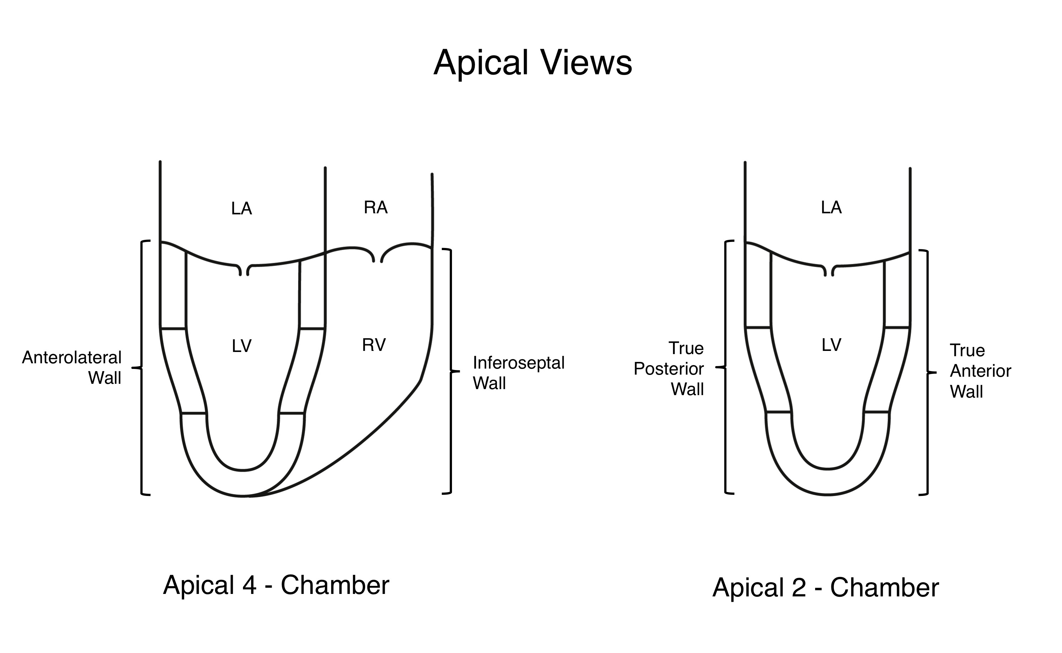
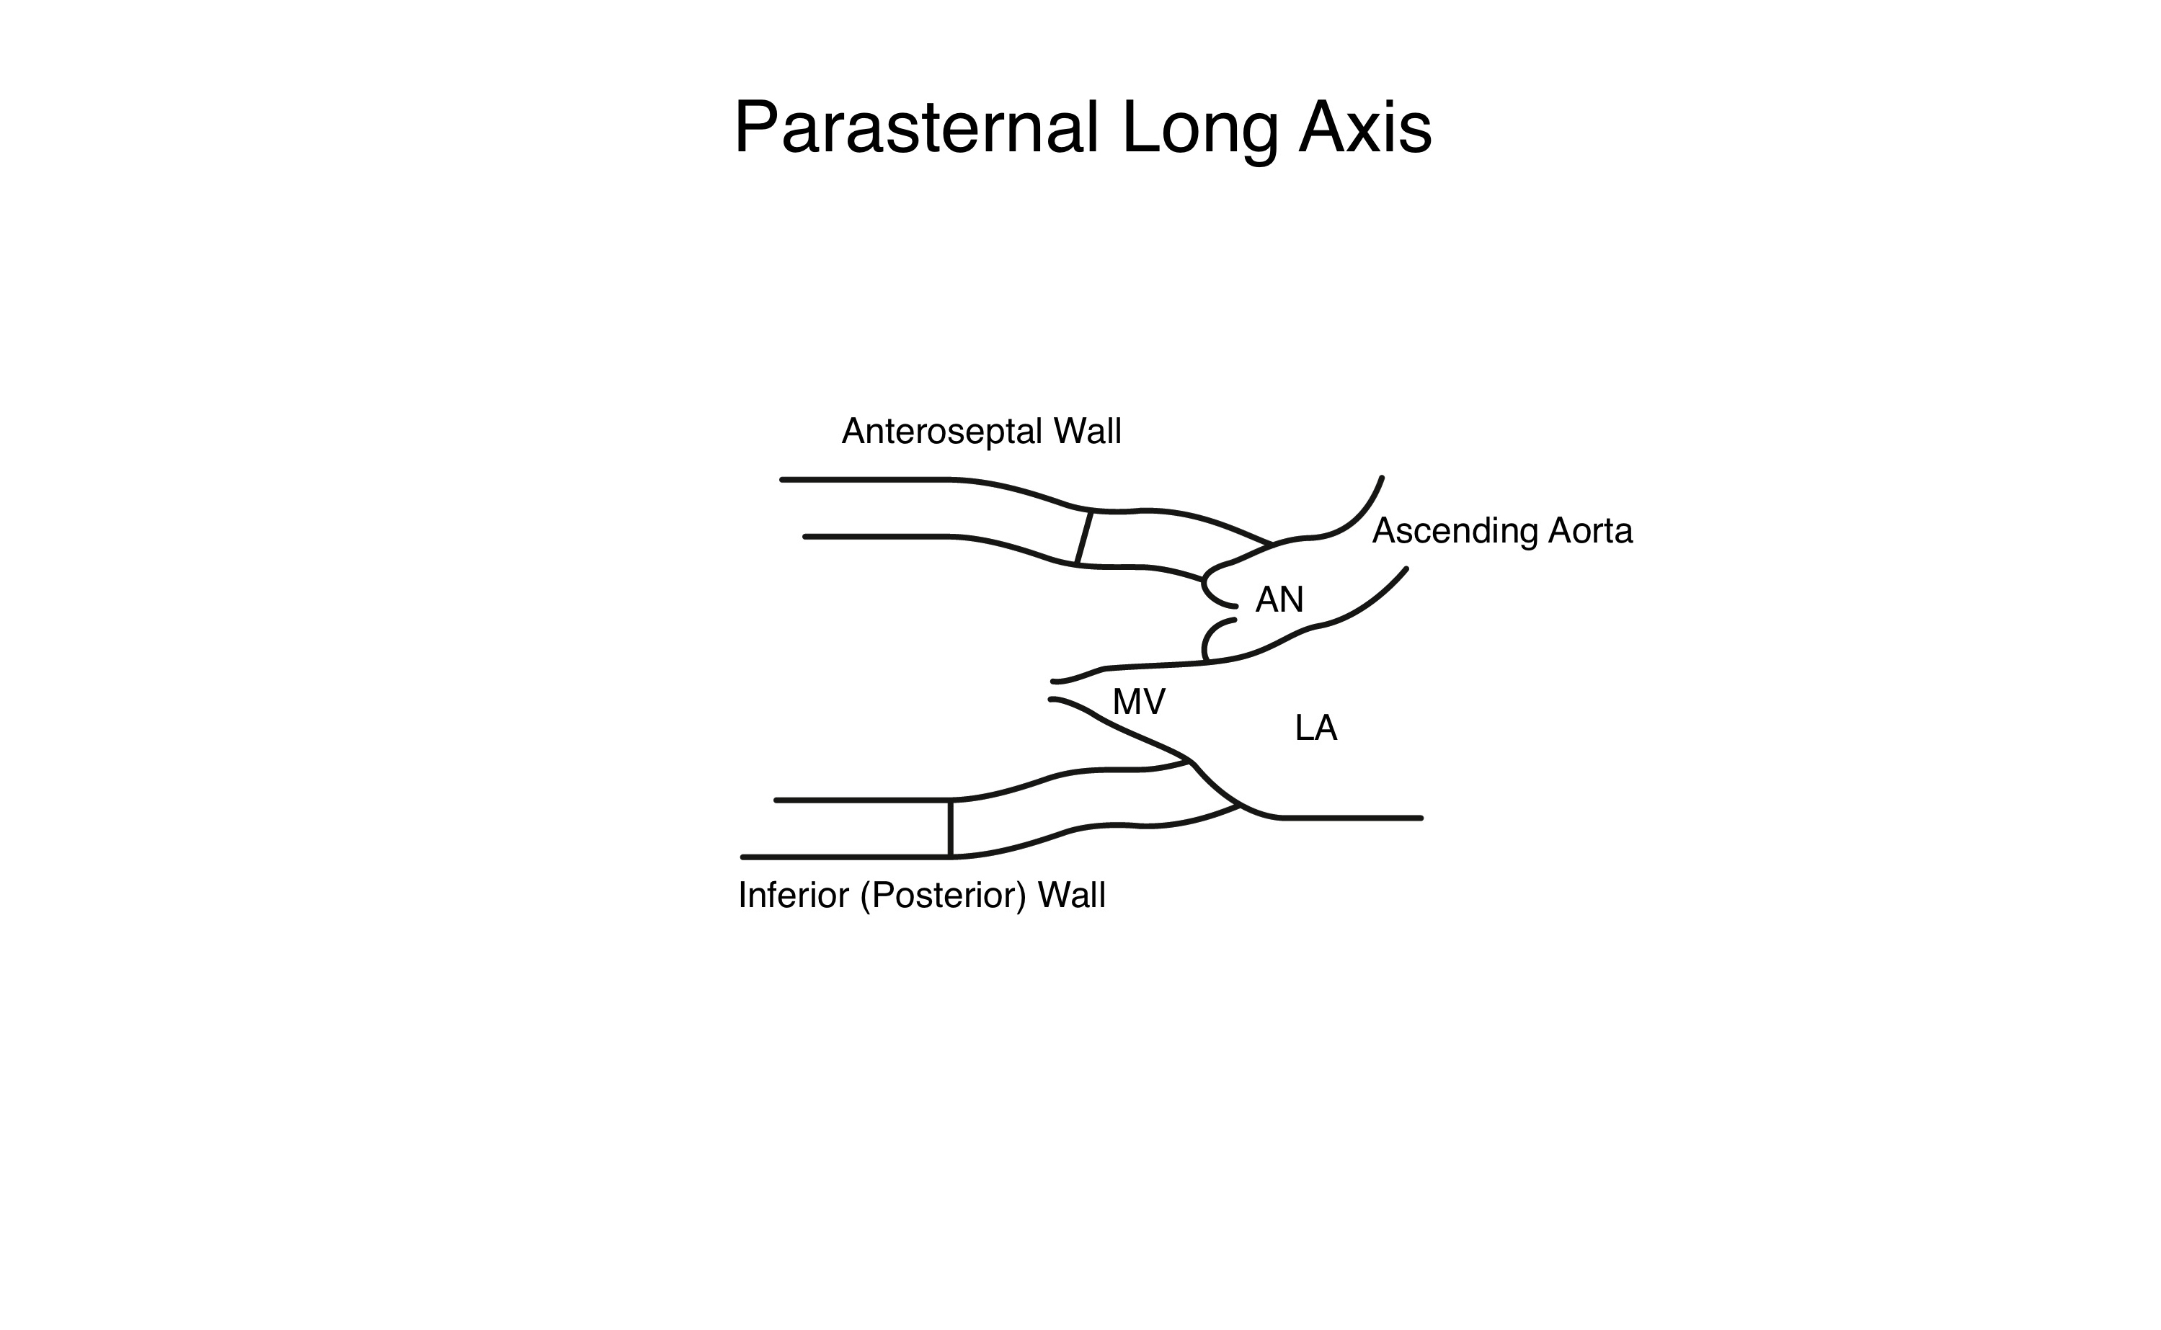

©Dept. Critical Care Medicine, Mater Misericordiae University Hospital
Reference Data:
Left Ventricular End Diastolic diameter:
 | Normal | Mildly dilated | Moderately dilated | Severely dilated
Men (cm) | 4-5.9 | 6.0-6.3 | 6.4-6.8 | >6.9
Women (cm) | 3.9-5.3 | 5.4-5.7 | 5.8-6.1 | >6.2

Fractional Shortening fraction %:

Normal : 25-45 Mild: 20-25 Moderate: 15-20 Severe: < 15

Ejection Fraction %:
Hyperdynamic LV function : > 65 Normal LV function: 55-60 Mild LV dysfunction: 45-54
Moderate LV dysfunction: 30-44 Severe LV dysfunction < 30

TAPSE:
Normal (mm) 24 ± 3.5 Abnormal < 17
Volume Assessment:
IVC size: < 1cm fluid responsive IVC > 2.5 cm fluid non-responsive (Feissel et al ICM 2004; 30:1834)

©Dept. Critical Care Medicine, Mater Misericordiae University Hospital
Calculations

©Dept. Critical Care Medicine, Mater Misericordiae University Hospital

