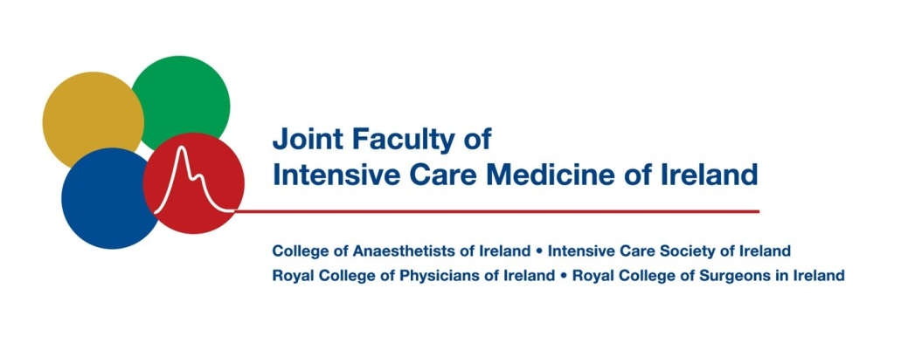
Credentials Committee
Terms of Reference

Purpose

The role of the credentials committee is to verify applications sent to the JFICMI from the Irish Medical Council (IMC) for doctors who have completed intensive care training in another jurisdiction or via an alternative route and are seeking inclusion on the Register of Medical Specialists as Specialists in Intensive Care Medicine.
Activity
The credentials committee will review the experience, training and qualifications of applicants and advise the IMC, having first informed the Board of the Faculty, on each applicant on a case by case basis.
The evaluation of applicants will be carried out taking into account the specified required criteria according with those specified within the SLA which will be applicable between the JFICMI and Medical Council of Ireland.

Meetings

The Committee shall meet three to four times per year and may when necessary, with the agreement of the Board, meet more frequently.

Sub-Committees

The Committee may, with the approval of the Board, establish a sub-committee with such terms of reference and so constituted as the Committee may determine, to consider any matter falling within the remit of the Committee and to report on that matter to the Committee.

Composition of the Committee and Review of Terms of Reference

These Terms of Reference (and Committee composition) shall be reviewed by the Committee at its first meeting in every administrative year i.e. the first meeting after the Annual AGM of the Faculty, and any recommended changes shall be submitted to the Board for approval.

